 | PAN Europe proposal on mixtures  Brussels, 27th November 2011.  Contact : Hans Muilerman, hans@pan-europe.info, tel. 0031655807255.

Preventing harmful effects of multiple chemical exposures on human health, a proposal of Pesticide Action Network Europe.

Summary.
Most proposals accounting for health effects of mixtures only cover the tip of iceberg. Some focus on common mechanism of action (Food Authority EFSA), some on concentration addition in case of known substances (SCHER-committee). But these approaches will miss the overwhelming majority of the cases of mixture exposures in practice which happen by exposure through air, food, dust, cosmetics, etc. Therefore these proposals are not protective enough and continue to put people, especially the vulnerable, at risk. We propose to take into account not only the tip of the iceberg but the iceberg as a whole in trying to cover risks of the millions and millions possible combinations of chemicals in daily life. The best option to do so is the use of an extra uncertainty factor in risk assessment (UF-mix) in addition to the ones used presently. The actual uncertainty factors used in risk assessment (10x10) are an underestimation of the actual risks and do not cover the effects on vulnerable groups like children. Based on academic studies available the extra uncertainty factor would be estimated to be at a level of 100. We propose to use this extra factor until good independent science provides for a better estimate.

1. Single chemical assessment is unrealistic and not a scientific basis for affording adequate protection for people or wildlife.
Exposure of man to a multitude of (synthetic) chemicals is the reality of the situation and yet the regulatory assessment of chemicals is typically based on the evaluation of the risks posed by exposure to a single substance in isolation. This unfortunate situation has now gone on for decades, but at last it seems that there is the political will to address this issue as a single substance assessment undoubtedly leads to the risks posed by chemicals being underestimated.

Synthetic chemicals are present in vegetables and fruit (pesticide residues), meat (antibiotics), fish (chlorinated chemicals) and processed foods (chemicals in packaging), which means that every day we are now exposed to multiple chemicals in our diet. On top of this, synthetic chemicals in clothes, in house dust, in cosmetics, in household chemicals and in the air result in further exposure to multiple chemicals. Finally, chemicals which have accumulated in our bodies as a result of lifelong exposure can provide ongoing exposure.
Yet in spite of this, EU risk evaluation of chemicals never takes all exposures via all the different routes into account, and sticks to the ‘one-chemical’ evaluation approach. An often used argument for inaction has been that good methodology is lacking. For example, even when the obligation to address cumulative exposure or so called ‘mixture effects’ was included in EU Directives (like the Residue Directive 2005), the EU Food Authority EFSA managed to spend over 6 years studying methods and delay action up to this moment. This is the case while methods for cumulative assessment are available in literature and used in the US already for many years. No matter these political manouvres,, scientific opinion is clear that something must be done to ensure health protection.

2. What is the method of choice to cover cumulative effects of chemicals?
For cumulative effects of well-known groups of chemicals with a similar mode of action like the organophosphates, polychlorinated biphenyls (PCBs) or the conazoles methods are available to make a calculation of the combined exposure. This is generally done by using a ‘relative potency factor’, bringing the members of the group under a common denominator. However this method can only be used for a very small number of groups with similar modes of action and will bring no solution for the scores of chemicals to which people are exposed every day, and the millions of possible chemical combinations possible.
The SCHER-panel goes one step further and proposes to also do an assessment in case the components of the mixtures are known (but not similarly acting) and proposes to use the method of “dose addition” in that case. But this again is no solution for the majority of the cases and the reality of the unknown mixtures of chemicals to which people are exposed. Analysing the components and testing the millions and millions of combinations of chemicals is no option. The only reasonable option to cover the overwhelming majority of the mixtures is to use a default uncertainty factor to protect people. Instead of focussing on the tip of the iceberg (known components) as EFSA and SCHER do, a better option, proposed here, would be to include the whole iceberg in the methodology.

3. Uncertainty on cumulative effects is not calculated.
Risk evaluation on chemicals already deals with several elements of uncertainty, and has derived what are called ‘uncertainty factors’ (UFs) to deal with these uncertainties. Sometimes these UFs have been termed ‘assessment factors’ or ‘safety factors’ but this latter term wrongly implies some safety margin, which as shown below is certainly not always the case. Therefore, the term uncertainty factors (UFs) is the preferred term used in this document. The elements that are commonly taken into account in regulatory risk assessment are:
- Interspecies Extrapolation: This uncertainty factor takes account of the possibility that humans are more susceptible to the harmful effects of the substance than the animals (for instance, rats) in which the NOAEL was estimated. Its default value is 10.
- Intra-Species Variation: This uncertainty factor reflects the fact that there are typically subgroups of the population, such as infants and the elderly, who are more susceptible than average. (Recall that the acceptable daily intake is intended to be protective of sensitive subgroups.) The intra-species uncertainty factor is important because populations of laboratory animals are normally much more homogeneous than human populations. Its default value is 10.
- Sub-Chronic to Chronic: Chronic exposure is exposure occurring over an extended period of time. This uncertainty factor, then, is used when the only available data derives from studies that examined only the effects of short-term exposure to the substance. Its default value is 10 in the US while ECHA recommends 6 (3 x 2 from subacute to subchronic to chronic).
- LOAEL to NOAEL: In some cases, animal experiments may fail a dose that does not produce an adverse effect. In this case, a lowest- observed-effect-level (LOAEL) is used as a basis for estimating the NOAEL, and an additional uncertainty factor with a default value of 10 is applied in US while ECHA recommends 3.
- Modifying Factor: This is an uncertainty factor for residual uncertainties not covered by the above uncertainty factors, such as incomplete data or flawed research designs in the available studies. This is the case in the US (it may vary from 1 to 10), but it is not used in Europe.

4. Will the uncertainty factors already in use not be “conservative” enough and cover the uncertainties regarding mixtures as well?
An uncertainty factor of 100 (10x10) is widely used to establish recommended health-based guidance values such as ADI and TDI. Does this factor adequately protect the entire population?
- Intra species variation (UF 10)
Studies to assess the variability in humans are not easy to perform. Best data are available in the area of pharmaceuticals where human trials and monitoring are practice.
Dorne et al. is one of the few scientists who studied a quantitative evaluation of the adequacy of the default factor for toxicokinetics (WHO subdivided the factor in 3,16 covering toxicokinetics and 3,16 covering toxicodynamics). Data were collected in literature on therapeutic drugs as probe substrate for Cytochrome P450, the main elimination pathway in humans. The outcome is that vulnerable groups would not be protected enough. Neonates will not be protected at all and a low protection is given to pregnant woman at term, healthy elderly and people with a liver disease. Healthy adults generally are protected by this factor though.
- Inter species extrapolation (UF 10)
For extrapolating from a dose–response relationship in a test species (dog, rabbit, rat and mouse) to a ‘‘safe’’ dose in humans there are differences in the underlying physiological
processes that affect the magnitude of the difference in the internal dose of a compound (e.g. liver weight, liver blood flow, cardiac output, renal blood flow, etc.) and also in the quantity and nature of the enzymes that contribute to the clearance of a toxicant.
Laboratory animals are usually less sensitive to toxic chemicals than humans; this is illustrated in the Figure below of data collected on effects of (anti-neoplastic) drugs in humans and test animals.

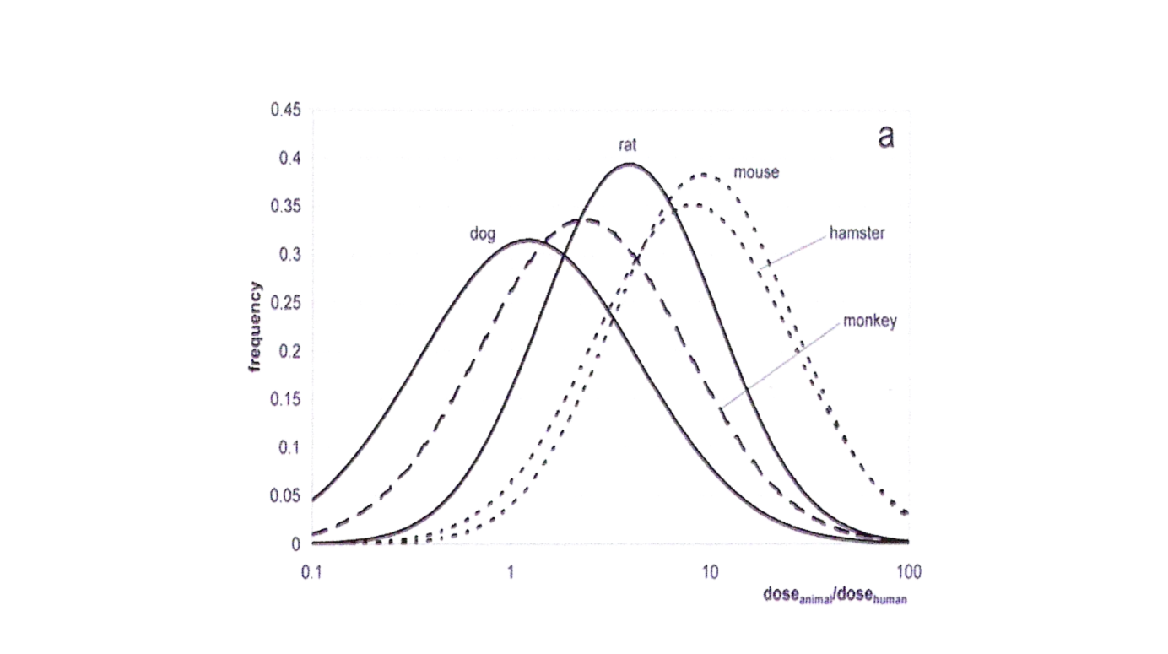
The Figure is from Schneider et al. (Forschungs- und Beratungsinstitut Gefahrstoffe GmbH (FoBiG) and it shows the density functions for specific ratios in relation to equally toxic doses for anti-neoplastic agents. Data on 63 neoplastic agents in 187 dose ratios were analysed and the maximum of the curves represent the mean differences. Schneider shows the differences can partly be explained by caloric demand of a species (factor 1,6-7 depending of the animal) and partly by dose effects which vary generally up to 7 but also in some cases much higher (up to 60). The combined factor will in many cases exceed the uncertainty factor of 10.

WHO again subdivided the factor 10 for inter species variability, but this time into 4.0- and 2.5-fold for toxicokinetic and toxicodynamic aspects, respectively. Studies suggest that the interspecies toxicokinetic default uncertainty factor of 4 would often be insufficient to cover differences in metabolism between humans and some commonly used laboratory animals. This depends on the animal and the pathway through which the chemical is metabolized. Walton et al. showed that mouse (10,6) and rat (5,4) generally exceed the 4,0 uncertainty factor, while two other test animals (rabbit, dog) are below this value.

In another study Walton et al., 2001 studied glucoronidation in human and test animals and the results showed that there are major interspecies differences in the nature of the biological processes which influence the internal dose, including the route of metabolism, the extent of presystemic metabolism and enterohepatic recirculation. Walton calculated mean (!) ‘clearance’ factors of rat compared to human of 21, of dog 8,6, mouse 5,5 and rabbit 0,95, figures which give an indication of the level of underestimation an animal study might give for the assessment of human toxicity.
Falk-Filipsson et al., reviewing the different studies on uncertainty factors, suggest a composite assessment factor (based on caloric demand X remaining uncertainty) of 28 for rat and 49 for mice inter species variability because the present factor only partly covers the distribution of the different substances studied. Further they suggest an uncertainty factor of minimal 15 for intra species variability. They also suggest extra uncertainty factors used for children.

Available studies show that the uncertainty factors use (10x10) are not sufficient to protect people. For interspecies extrapolation the factor 10 is a underestimation of the factors necessary for many substances and species; for intra species extrapolation the vulnerable groups are not protected. The conclusion is the UF of 10x10 in use is in several cases not protective enough and certainly doesn’t cover other effects like effects of mixtures.

5. Statistical methods not useful.
Several authors of publications suggest the uncertainty factors used are “over-conservative”, claiming ’worst-case’ is put on top of ‘worst-case’ based on statistical arguments, not science. They start proposing methods, mainly cut-off values from probabilistic distributions, to reduce the uncertainty factors. But the probabilistic tool just excludes the extreme scores from a database and one has no idea what this means in terms of risks and human protection.

In effect this will lead to X% of people protected for Y% of chemicals. EU Treaty guarantees a high level of protection and Regulation 1107/2009 translates this for chemicals in the condition they shall not have immediate or delayed harmful effect on human health, including that of vulnerable groups, This means individuals need to be protected and not 100-X% excluded from protection like in cut-offs based on probabilistic distributions. Statistical methods therefore shouldn’t be used in human risk assessment.

6. Proposals for the uncertainty factor calculating mixtures (UF-mix).
Backhaus et al. propose to use an extra uncertainty factor as a very pragmatic way to account for the fact that not only the particular substance that is subject to evaluation might be harmful to exposed humans and organisms in the environment – but that in fact it may become part of a multicomponent mixture, whose cumulative impact can be expected to be higher than that of each individual chemical present. The authors conclude that there is a need to determine the factor better, but based on the scarce information available they argue for a UF-mix between 10 and 100.

However, it needs to be recognised that for some chemicals, mixtures risk assessment is not the best option as certain chemicals need to be more tightly regulated and substituted with safer substances on the basis of their hazard properties. For example, PAN-Europe considers that the goal should be to eliminate exposure, wherever possible, to substances of very high concern, such as chemicals with endocrine disrupting properties. For the latter chemicals, there are well-founded concerns that they are impacting health in the population as they have been linked with adverse trends in male reproductive health, increases in hormone related cancers (including those of the breast, testes, prostate), obesity and diabetes. The goal to eliminate exposure, rather than impose a mixture assessment using a UF-mix, would be in line with the requirements of the new Pesticides Regulation 1107/2009, which requires that pesticides with endocrine disrupting properties are phased out unless exposure is negligible.

7. Conclusion of PAN-Europe.
It is far too narrow an approach to limit mixture assessment to chemicals with a similar mode of action or only to known chemicals. The overwhelming majority of the mixtures in practice will be missed doing so. Claims saying the actual risk assessment is 'overconservative' and might cover already the effects of mixtures, are not supported by literature. In fact literature shows that the interspecies uncertainty factors used are an underestimation of the risks, and the intraspecies uncertainty factors do not protect children. Therefore, the best option is to impose an additional UF-mix in the human risk assessment. This UF-mix should also include effects of external stressors, which are well known to impact on the risk from chemicals. For example, Holmstrup et al. reported synergistic effects between natural stressors and chemical stressors in 50% of the cases. To fully account for mixture toxicity and include all negative effects on humans and wildlife, and also include the (often synergistic) effects of natural stressors, an extra uncertainty factor, the UF-mix is needed, estimated to be at a level of 100. The UF-mix should be implemented as soon as possible, to address the neglect of the past.

Toxicity and Assessment of Chemical Mixtures; Preliminary Opinion approved for Public Consultation, May 2011
Daniel Steel, Extrapolation, uncertainty factors, and the precautionary principle, Studies in History and Philosophy of Biological and Biomedical Sciences 42 (2011) 356–364
J.L.C.M Dorne, J.Walton and A.G. Renwick, Uncertainty factors for human risk assessment: human variability in the pharmacokinetics of CYP1A2 probe substrates, Food and Chemical Toxicology 39 (2001) 681-696.
K. Schneider at al. Uncertainty analysis in workplace effect assessment, Bundesanstalt fur Arbeitsschutz und Arbeitsmedicin, Research report F1824/1825/1826, 2005
K.Walton, J.L.Dorne and A.G.Renwick, Uncertainty factors for risk assessment: interspecies differences in the in vivo pharmacokinetics and metabolism of human CYP1A2 substrates, Food and Chemical Toxicology 39 (2001) 667-680.
K. Walton, J.L. Dorne, A.G. Renwick, Uncertainty factors for chemical risk assessment: interspecies differences in glucuronidation, Food and Chemical Toxicology 39 (2001) 1175–1190
Agneta Falk-Filipsson, Annika Hanberg, Katarina Victorin, Margareta Warholm, Maria Walle´, Assessment factors—Applications in health risk assessment of chemicals, Environmental Research 104 (2007) 108–127
If effects on the endocrine, reproductive, immune and the nervous systems are suspected or indicated, particularly in young individuals, specially designed animal studies including the relevant age period are necessary to make an adequate risk assessment. If adequate knowledge is lacking, we propose an extra assessment factor of 1–10 as a default value to protect children. Gender differences in sensitivity may also need to be compensated for.
Probabilistic assessment factors for human health risk assessment, T.Vermeire, M.Pieters, M.Rennen and P.Bos, NL RIVM/TNO report, March 2001.
Hazard and Risk Assessment of Chemical Mixtures under REACH, State of the Art, Gaps and Options for Improvement, Thomas Backhaus, Hans Blanck Michael Faust, Swedisk Chemical Agency, KEMI, June 2010.
Martin Holmstrup, Anne-Mette Bindesbøl, Gertie Janneke Oostingh, Albert Duschl, Volker Scheil, Heinz-R. Köhler, Susana Loureiro, Amadeu M.V.M. Soares, Abel L.G. Ferreira, Cornelia Kienle, Almut Gerhardt, Ryszard Laskowski, Paulina E. Kramarz, Mark Bayley, Claus Svendsen, David J. Spurgeon, Interactions between effects of environmental chemicals and natural stressors: A review, Science of the Total Environment 408 (2010) 3746–3762.

